UNIT - 5

**EVENT DRIVEN PROGRAMMING**

Question Bank

**PART – A**

**2 – Marks**

1. What is Applet?

Applet is java program that runs on web browser. It has a life cycle that managed by browser. Applet programs served as web applications. Due to some security reasons the applets are deprecated and browsers no longer support for applets.

1. Draw the life cycle of applet.

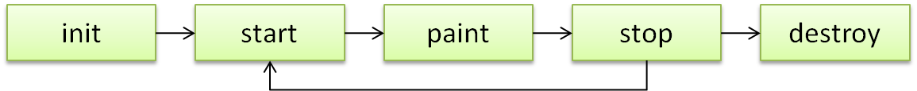

1. Give a short note on awt package in java.

Java AWT (Abstract Window Toolkit) is an API to develop GUI or window-based applications in java. Java AWT components are platform-dependent i.e. components are displayed according to the view of operating system. AWT is heavyweight i.e. its components are using the resources of OS. The java.awt package provides classes for AWT api such as TextField, Label, TextArea, RadioButton, CheckBox, Choice, List etc.

1. What is frame in java awt? Give some properties of frames.

The Frame is the container that contain title bar and can have menu bars. It can have other components like button, textfield etc. Properties of frames as follows,

* Icon – Image
* Title – Information about frame
* Size – Display size [length and breadth specified in pixels]
* Visibility – Hides and Shows the frame based on [true or false value]

1. Give short note on drawOvel method from Graphics class.

drawOvel is a method available in Graphics class from awt package. It helps to draw circle or ellipse/ovel using graphics object. It receives four arguments that help to draw eg: g.drawOvel(x, y, length, width).

1. Write a code that displays hello world in a frame using Label.

class MyCanvas extends Canvas{

public void paint(Graphics g) {

g.drawString("HelloWorld", 100, 100);

}

}

class MyFrame extends Frame{

public MyFrame() {

add(new MyCanvas());

setSize(500, 500);

setTitle("Frame With String");

setVisible(true);

}

}

public class Main {

public static void main(String[] args) {

new MyFrame();

}

}

***Output:***

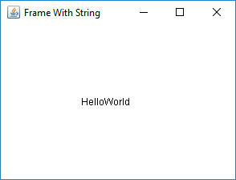

1. Define Canvas class in java.

Canvas control represents a rectangular area where application can draw something or can receive inputs created by user.

1. What is event driven programming?

In computer programming, event-driven programming is a programming paradigm in which the flow of the program is determined by events such as user actions (mouse clicks, key presses), sensor outputs, or messages from other programs/threads.

1. List some event handler classes in java.

There are many event handler classes available in java

* Window Event
* Mouse Event
* Action Event
* Key Event

1. What is the use of adapter classes in event handling?

Java adapter classes provide the default implementation of listener interfaces. If you inherit the adapter class, you will not be forced to provide the implementation of all the methods of listener interfaces. ... The adapter classes are found in java.awt.event, java.awt.dnd and javax.swing.event packages.

1. List all the methods defined in Mouse Listener interface.

* Mouse Entered
* Mouse Exited
* Mouse Pressed
* Mouse Released
* Mouse Clicked

1. Give a short note on swing in java.

Java Swing is a part of Java Foundation Classes (JFC) that is used to create window-based applications. It is built on the top of AWT (Abstract Windowing Toolkit) API and entirely written in java. Unlike AWT, Java Swing provides platform-independent and lightweight components. The javax.swing package provides classes for java swing API such as JButton, JTextField, JTextArea, JRadioButton, JCheckbox, JMenu, JColorChooser etc.

1. What is use of BorderLayout?

The BorderLayout is used to arrange the components in five regions: north, south, east, west and center. Each region (area) may contain one component only. It is the default layout of frame or window. The BorderLayout provides five constants for each region:

* public static final int NORTH
* public static final int SOUTH
* public static final int EAST
* public static final int WEST
* public static final int CENTER

1. List some swing components with its usage.

JPanel – It is container used to place other components.

JButton – Button used to control components by actions.

JTextField – Used to get the text.

JRadioButton – Helps to get options from users

1. Give a short note on grouping a radio buttons in swing.

Grouping radio buttons are button group is used to select only one button from the set. A set of buttons ware created and added to group object. Then only one radio button can be selected by the user.

1. Write a program that helps to get input from user using dialog box.

**import** javax.swing.*;

**class** MyFrame **extends** JFrame{

String name;

**public** MyFrame() {

name = JOptionPane.*showInputDialog*("Enter Your Name");

add(**new** JLabel("Hello "+name + " !!!"));

setSize(300,300);

setVisible(**true**);

}

}

**public** **class** Main {

**public** **static** **void** main(String[] args) {

**new** MyFrame();

}

}

**PART – B**

**13 -Marks**

1. Write a program that draws basic shapes using applet.
2. Write an awt program that draws shapes using Graphics2D classes.
3. Write an awt program to drawlines based on mouse clicks.
4. Write a program to draw a rectangle using canvas and grow the circle when click inside.
5. Write a program that helps to calculate emi details based on interest and tenure.
6. Write a program that shows basic file handling menus [File, Edit, Format, View, Help].